

***UNIVERSITY OF ENGINEERING AND TECHNOLOGY PESHAWAR, JALOZAI CAMPUS***

***_ _***

# PROJECT PROPOSAL

***MICRO-CONTROLLER***

***PROJECT MEMBERS***

**Azaz Hassan Khan** (18JZELE0262)

**Abbas Ali** (18JZELE0237)

**Abdullah Shah** (18JZELE0236) **Mohsin Nawab** (18JZELE0283)

## SUBMITTED TO

**DR. UMAR SHARIF**

**MINI-PROJECT OF MICROCONTROLLER**

**PROJECT TITLE**

Controlling Slave Microcontroller with Boss Microcontroller with the help of **Serial Communication.**

**OBJECTIVE**

* **Sensing Signals** from Sensors and converting it into digital form through **ADC808.**
* Controlling devices through Salve microcontroller on the bases of data which is received from **ADC808.**
* Sending the Readings of Data from Slave to Master through **Serial Communication**.

**SUMMARY**

Sensors will Sense the signals and send it to ADC808, Then ADC808 will convert the receive analog data into the digital data and send it to the Slave Microcontroller then Slave Microcontroller operate the associated devices automatically on the bases of data it received from the ADC808.

Now, when **Master Microcontroller** requires a certain information about sensors reading then the **Master** send a signal to the **Slave Microcontroller** to send the required information of the sensor then the **Slave** will sends the required information of the sensors which is ordered by **Master Microcontroller**.

**APPARATUS:**

* Two Microcontrollers (Master and Slave)
* ADC808
* Temperature sensor **LM35**
* Pressure sensor **MPX4115**
* Voltage sensor
* Wires (BUS BAR WIRING)
* Stepper Motor
* DC Motor
* OPTO Relay **4N25**
* Keypad
* LCD **32 bit**
* ULN2003A Chip
* Mechanical Relay
* DC and Ac Source

**SOFTWARE USED :** PROTIUS VERSION 8.0

**Master**-**Slave pattern**

**THEORY:**

The **Master**-**Slave pattern** is often used for multi-threaded applicationsin which many instances of the same problem must be solved. The **master** creates and launchesslaves to solve these instances in "parallel".When all of the slaves have finished, the **master** harvests the results. Master/slave is a model of communication for hardware devices where one device has a unidirectional control over one or more devices. This is often used in the electronic hardware space where one device acts as the controller, whereas the other devices are the ones being controlled.

## ADC0808

The ADC0808, ADC0809 data acquisition component is a **monolithic CMOS device** with an 8-bit analog-to-digital converter, 8-channel multiplexer and microprocessor compatible control logic. The 8-bit A/D converter uses successive approximation as the conversion technique.

## LM35

LM35 is a **temperature** measuring device having an analog output voltage proportional to the **temperature**. It provides output voltage in Centigrade (Celsius). It does not require any external calibration circuitry. The sensitivity of **LM35** is 10 mV/degree Celsius.

## Pressure sensor

A pressure sensor is a device for pressure measurement of gases or liquids. Pressure is an expression of the force required to stop a fluid from expanding, and is usually stated in terms of force per unit area. A pressure sensor usually acts as a transducer; it generates a signal as a function of the pressure imposed.

## Stepper Motor

A stepper motor, also known as step motor or stepping motor, is a brushless DC electric motor that divides a full rotation into a number of equal steps.

## DC motor

A DC motor is any of a class of rotary electrical motors that converts direct current electrical energy into mechanical energy. The most common types rely on the forces produced by magnetic fields.

## Optically-isolated relays

are characterized by the use of a light emitting diode (LED) on their input side, MOSFETs on the output side and an array of photo sensors in between. In operation, current flows through the LED, which emit light. The MOSFETs finally switch the load circuit.

## ULN2003A Chip

The ULN2003A is an array of seven NPN Darlington transistors capable of 500 mA, 50 V output. It features common-cathode flyback diodes for switching inductive loads. It can come in PDIP, SOIC, SOP or TSSOP packaging.

## BLOCK DIAGRAM:

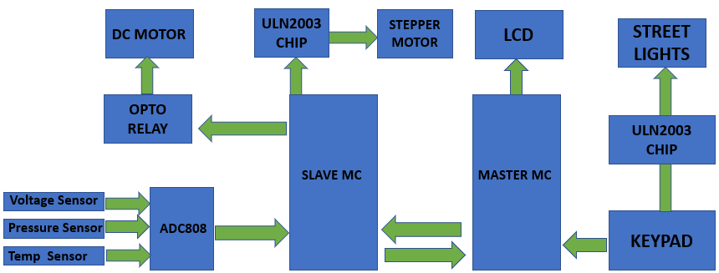

**CIRCUIT DIAGRAM:**

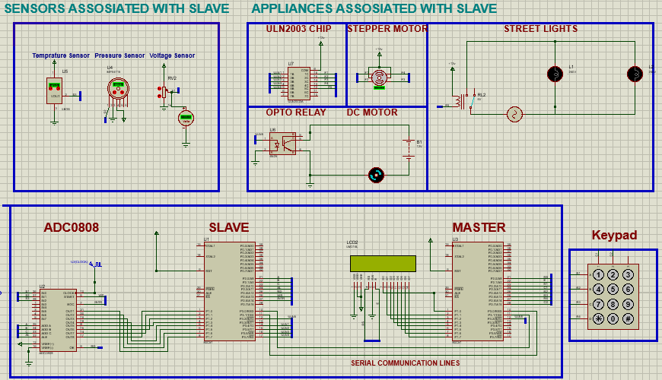

**STEPS OF CONNECTION IN PROTEUS:**

* 1. First of all, open the Proteus software and create a new project.
  2. Now first of all Start with sensors select the required sensors from the **Proteus Library**

and do the required connections as seen in the circuit diagram.

* 1. Then select the **ADC808** from Proteus and connect the three Sensors which has been selected in the previous step with the **ADC808**
  2. Now, connect the ADC808 with the **slave microcontroller** through Port 1.
  3. Then, connect the Stepper Motor with ULN2003 Chip and Dc Motor with OPTO Relay.
  4. Now, connect Both the ULN2003 Chip and OPTO Relay with Microcontroller
  5. Now, connect the Slave Microcontroller with the **Master Microcontroller** Though Port 3^0 and 3^1.
  6. Now, connect the **LCD with Master Microcontroller** through Port 1 and also attached the **Keypad with Master Microcontroller** through Port 2.
  7. Hence, our connections have completed.
  8. Now, the last step is to **embed the c coding in master and slave microcontroller.**

## WORKING PROCEDURE OF PROJECT:

1. Now, start the Proteus Simulation by Pressing the Run Button in the Lower left Corner of the Proteus Interface.
2. Now, you will See **Starting…** and then after starting you will see a **Requesting…** string on the LCD.
3. Now the Project is Ready to **Simulate.**

## Temperature Control Dc Motor:

1. Now, if the **Temperature** is above the **39 centigrade** the **Dc Motor** will Start Automatically and if its falls below 40 then Dc motor will turn off automatically. Pressure Control Stepper Motor:

## Pressure Control Stepper Motor:

1. Now if the Pressure is below the 50pa the Stepper motor will remain at 0 angle but if the Pressure increases above the 50 Pathe Stepper motor will automatically rotate by 45- degree angle and if its increase Furter above 60 the motor will rotate 90 degree and it will rotate by every increase in pressure by 45 degrees.
2. Now, voltage has no device attached to it to operated. So, now we will move towards master microcontroller.
3. **Master** will send the order to Slave to sends the information of certain Senor by using keypad.

## Usage Of Keypad:

1. When we press ‘1’ on the keypad master will receive the **Voltage sensor** Information and will also display on the LCD.
2. When we press ‘2’ on the keypad master will receive the **Temperature sensor**

Information and will also display on the LCD.

1. When we press ‘3’ on the keypad master will receive the **Pressure sensor** Information and will also display on the LCD.
2. When we press * on the keypad master will turn on the street lights and if we press 2 then the street lights will be turned on.

## CONCLUSION:

We concluded from this mini project that how we can communicate two microcontrollers through serial communication. Also, we covert analog data of sensors to digital form with the help of **ADC0808.** After that, we send that digital data to Slave microcontroller to control different devices according to it.

With the help of Keypad, we transmit a request for a Voltage, Temperature and Pressure sensors from Master which is then received by Slave microcontroller. After that, Slave microcontroller transmit a byte of data of sensors according to the Keypad press button on the Master microcontroller side and received it and shows the given information of sensors on the LCD. Also, we control several devices on temperature and pressure sensor which is clearly shown in the uploaded Vedios.

***END OF MINI PROJECT PROPOSAL***